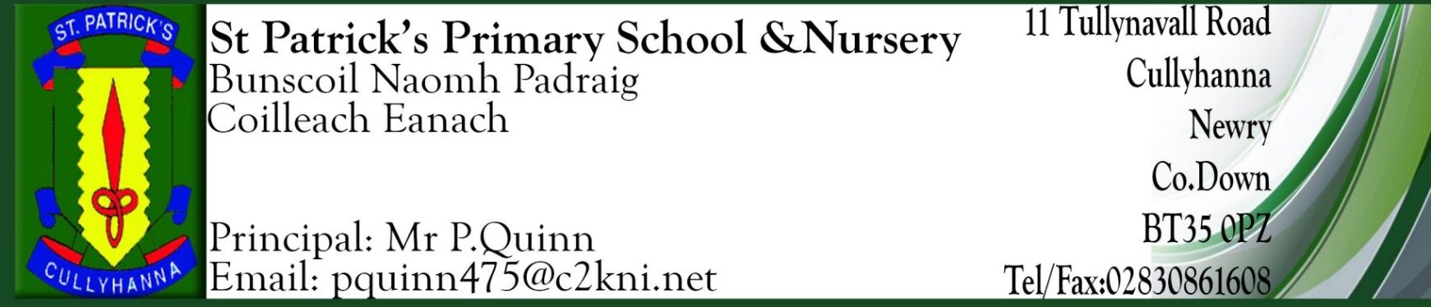

School Closures 2023/2024

October 2023
Monday 30st Oct – Friday 3rd November
Staff Development / Mid Term Break

November
Friday 17th November - Parent/Teacher meetings - no children

December 2023
Thursday 21st December – Half day - School closes at 12
for the Christmas Holidays.

January 2024
Monday 1st- Friday 5th January – Christmas holidays/Staff Development Day – Pupils off
Monday 8th - Pupils return to school.

February 2024
Monday 12th – Friday 16th February – School closed
Staff Development / Mid Term break

March 2024
Monday 18th March – School Closed
St Patrick’s Day

March/April 2024
Thursday 28th March – Half day - 12pm finish
Good Friday 29th March – Friday 5th April - Easter Holidays
Monday 8th April – Pupils return to school
May 2024
Monday 6th May – Bank Holiday
Friday 24th May & Monday 27th May
Staff Development & Bank Holiday

June 2024
Friday 28th - School Closes at 12pm for the Summer Holidays

Holy Communion – Saturday 4th May 2024

Confirmation date will be forwarded to you as soon as we receive it.

Parents are strongly urged to arrange family holidays on these dates.

We will endeavour to keep to these dates but if an emergency arises changes may occur. We will keep you informed if this happens.

Please keep the school informed of any changes to your contact details.

Yours Sincerely
P. Quinn
Principal

